**Question**

Write a Python program to demonstrate data preprocessing steps: handling missing values, encoding categorical data, and feature scaling.

1. Load a sample dataset using pandas (e.g., Iris and Wine datasets).

2. Plot the distribution of a feature using matplotlib.pyplot.hist().

3. Create scatter plots to understand relationships between features using seaborn.scatterplot().

4. Use a correlation heatmap to find the relationship between multiple features with seaborn.heatmap().

**Iris Dataset**

**Source Code**

import pandas as pd

import numpy as np

import matplotlib.pyplot as plt

import seaborn as sns

from sklearn.preprocessing import LabelEncoder, StandardScaler

# Loading dataset

dataset_url = "https://archive.ics.uci.edu/ml/machine-learning-databases/iris/iris.data"

columns = ['sepal_length', 'sepal_width', 'petal_length', 'petal_width', 'class']

iris = pd.read_csv(dataset_url, header=None, names=columns)

print(iris)

# Imputation not needed due to no missing values

# Label Encoding the classes (textual data -> numerical)

label_encoder = LabelEncoder()

iris['class'] = label_encoder.fit_transform(iris['class'])

# Feature scaling

scaler = StandardScaler()

iris[['sepal_length', 'sepal_width', 'petal_length', 'petal_width']] = scaler.fit_transform(

iris[['sepal_length', 'sepal_width', 'petal_length', 'petal_width']]

)

# Plotting the frequency distribution of Sepal Length

plt.figure(figsize=(6, 4))

plt.hist(iris['sepal_length'], bins=20, color='blue', alpha=0.7, edgecolor='black')

plt.title('Distribution of Sepal Length', fontsize=16)

plt.xlabel('Sepal Length', fontsize=12)

plt.ylabel('Frequency', fontsize=12)

plt.grid(True)

plt.show()

# Scatter plot relating Sepal Length and Petal Length

plt.figure(figsize=(6, 4))

sns.scatterplot(data=iris, x='sepal_length', y='petal_length', hue='class', palette='Set2')

plt.title('Scatter Plot: Sepal Length vs Petal Length', fontsize=16)

plt.xlabel('Sepal Length', fontsize=12)

plt.ylabel('Petal Length', fontsize=12)

plt.legend(title='Class')

plt.show()

# Correlation heatmap

plt.figure(figsize=(8, 6))

corr_matrix = iris.corr()

sns.heatmap(corr_matrix, annot=True, cmap='coolwarm', fmt='.2f', linewidths=0.5)

plt.title('Correlation Heatmap', fontsize=16)

plt.show()

**Output**

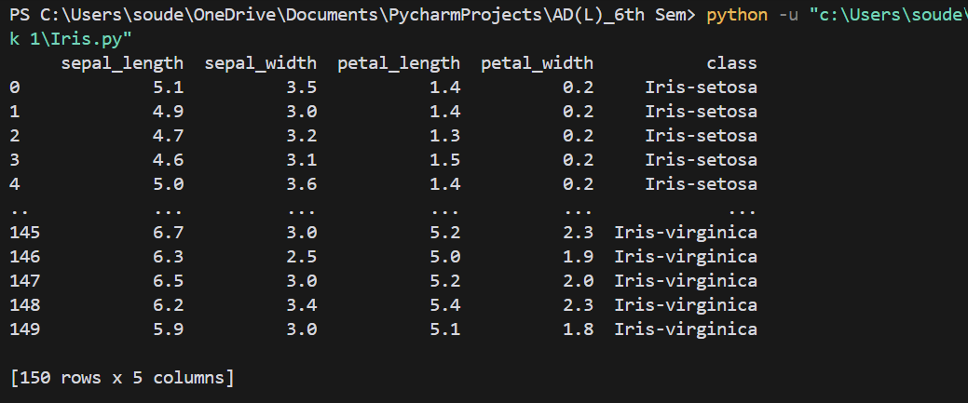*Terminal*

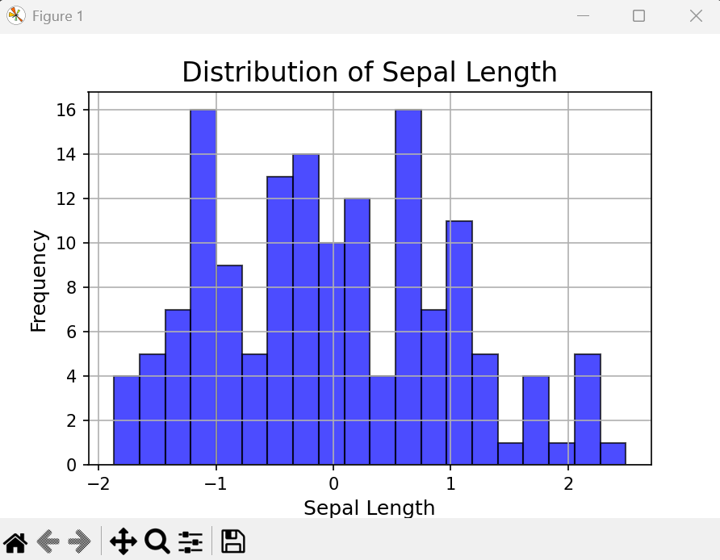

*Plot of distribution of Sepal Length using Pyplot*

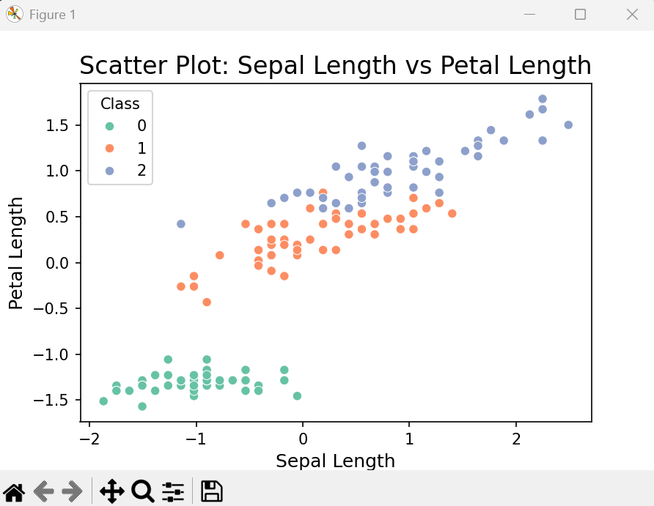

*Scatter plot of Sepal Length vs Petal Length using Seaborn*

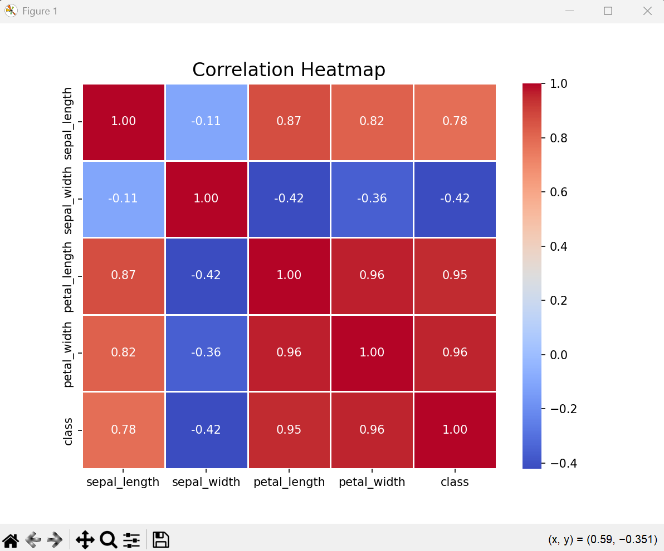*Feature Correlation Heatmap*

**Wine Dataset**

**Source Code**

import pandas as pd

import numpy as np

import matplotlib.pyplot as plt

import seaborn as sns

from sklearn.preprocessing import LabelEncoder, StandardScaler

# Load the Wine dataset

dataset_url = "https://archive.ics.uci.edu/ml/machine-learning-databases/wine/wine.data"

columns = ['class', 'alcohol', 'malic_acid', 'ash', 'alcalinity_of_ash', 'magnesium', 'total_phenols', 'flavanoids',

'nonflavanoid_phenols', 'proanthocyanins', 'color_intensity', 'hue', 'od280/od315_of_diluted_wines', 'proline']

wine = pd.read_csv(dataset_url, header=None, names=columns)

print(wine.head())

# Handling missing values

print(wine.isnull().sum()) #Print the number of missing values

# No imputation needed due to no missing value

# Feature scaling

scaler = StandardScaler()

wine.iloc[:, 1:] = scaler.fit_transform(wine.iloc[:, 1:])

# Plotting the distribution of a Alcohol

plt.figure(figsize=(6, 4))

plt.hist(wine['alcohol'], bins=20, color='blue', alpha=0.7, edgecolor='black')

plt.title('Distribution of Alcohol', fontsize=16)

plt.xlabel('Alcohol (scaled)', fontsize=12)

plt.ylabel('Frequency', fontsize=12)

plt.grid(True)

plt.show()

# Scatter plot of *Alcohol vs Color Intensity*

plt.figure(figsize=(6, 4))

sns.scatterplot(data=wine, x='alcohol', y='color_intensity', hue='class', palette='Set2')

plt.title('Scatter Plot: Alcohol vs Color Intensity', fontsize=16)

plt.xlabel('Alcohol (scaled)', fontsize=12)

plt.ylabel('Color Intensity (scaled)', fontsize=12)

plt.legend(title='Class')

plt.show()

# Correlation heatmap

plt.figure(figsize=(8, 6))

corr_matrix = wine.iloc[:, 1:].corr()

sns.heatmap(corr_matrix, annot=True, cmap='coolwarm', fmt='.2f', linewidths=0.5)

plt.title('Correlation Heatmap', fontsize=16)

plt.show()

**Output**

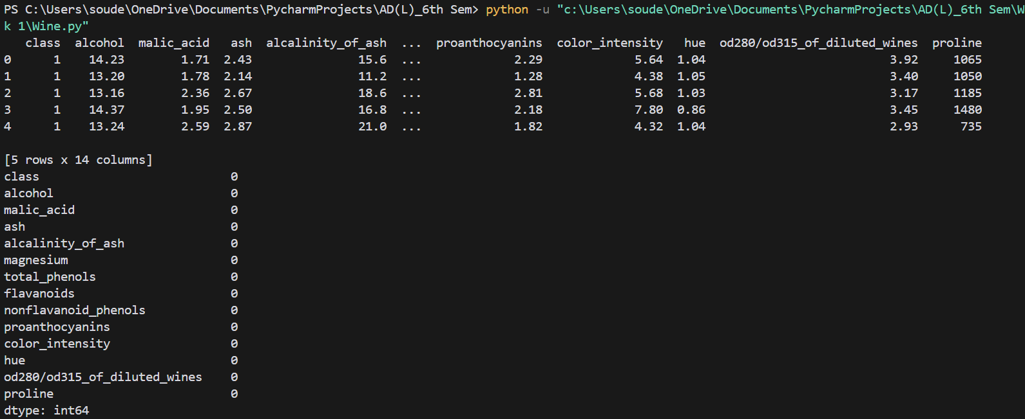*Terminal*

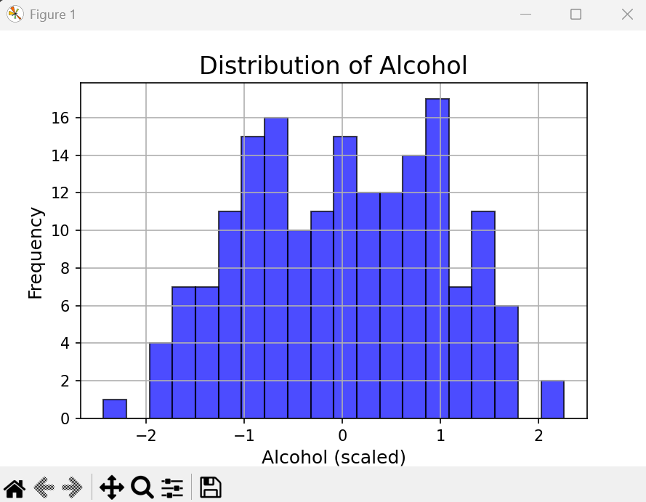

*Plot of distribution of Alcohol using Pyplot*

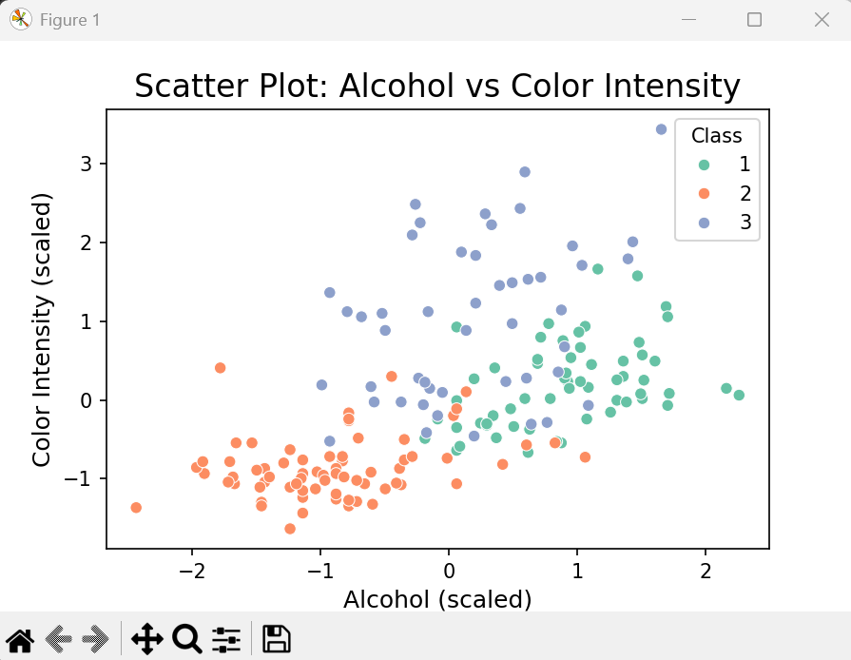

*Scatter plot of Alcohol vs Color Intensity using Seaborn*

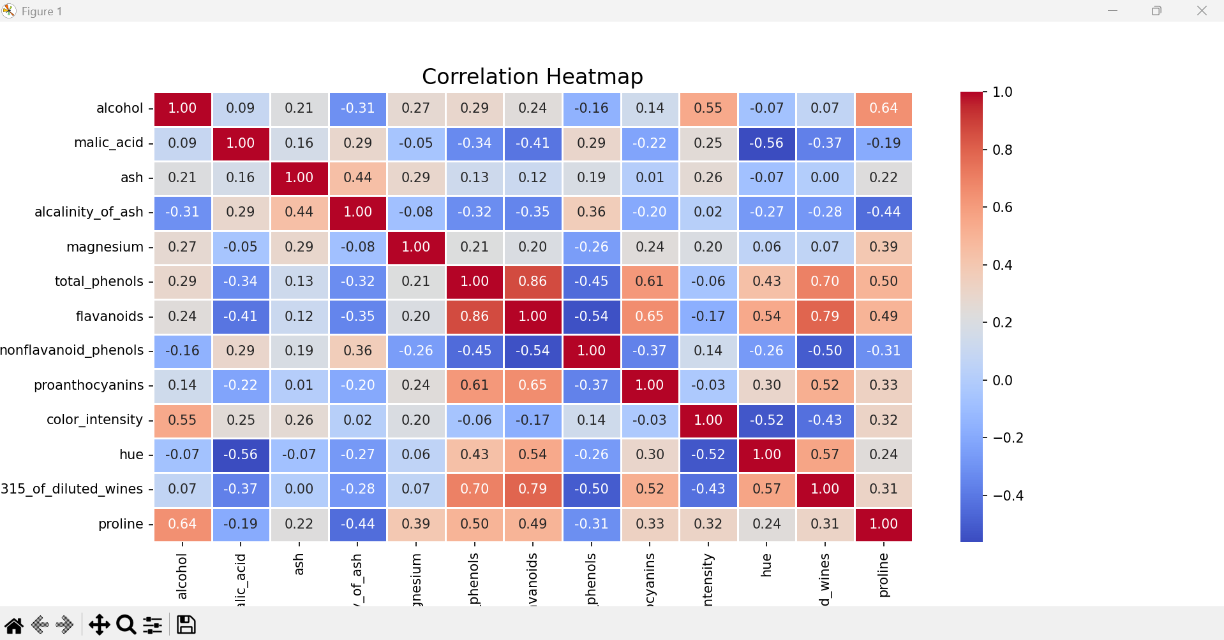*Feature Correlation Heatmap*